**Spring Core and Maven**

**Exercise 1: Configuring a Basic Spring Application**

**Scenario:**

Your company is developing a web application for managing a library. You need to use the Spring Framework to handle the backend operations.

**Steps:**

1. Set Up a Spring Project:
   * Create a Maven project named LibraryManagement.
   * Add Spring Core dependencies in the pom.xml file.
2. Configure the Application Context:
   * Create an XML configuration file named applicationContext.xml in the src/main/resources directory.
   * Define beans for BookService and BookRepository in the XML file.
3. Define Service and Repository Classes:
   * Create a package com.library.service and add a class BookService.
   * Create a package com.library.repository and add a class BookRepository.
4. Run the Application:
   * Create a main class to load the Spring context and test the configuration.

**CODE:**

**BookRepository.java:**

package com.library.repository;

public class BookRepository {

public void saveBook(String bookName) {

System.*out*.println("Book saved: " + bookName);

}

}

**BookService.java:**

package com.library.service;

import com.library.repository.BookRepository;

public class BookService {

private BookRepository bookRepository;

public void setBookRepository(BookRepository bookRepository) {

this.bookRepository = bookRepository;

}

public void addBook(String bookName) {

bookRepository.saveBook(bookName);

}

}

**applicationContext.xml:**

<?xml version="1.0" encoding="UTF-8"?>

<beans xmlns="http://www.springframework.org/schema/beans"

xmlns:xsi="http://www.w3.org/2001/XMLSchema-instance"

xsi:schemaLocation="

http://www.springframework.org/schema/beans

http://www.springframework.org/schema/beans/spring-beans.xsd">

<bean id="bookRepository" class="com.library.repository.BookRepository" />

<bean id="bookService" class="com.library.service.BookService">

<property name="bookRepository" ref="bookRepository"/>

</bean>

</beans>

**MainApp.java:**

package com.library.main;

import org.springframework.context.ApplicationContext;

import org.springframework.context.support.ClassPathXmlApplicationContext;

import com.library.service.BookService;

public class MainApp {

public static void main(String[] args) {

ApplicationContext context = new ClassPathXmlApplicationContext("applicationContext.xml");

BookService service = (BookService) context.getBean("bookService");

service.addBook("Spring in Action");

}

}

**OUTPUT:** 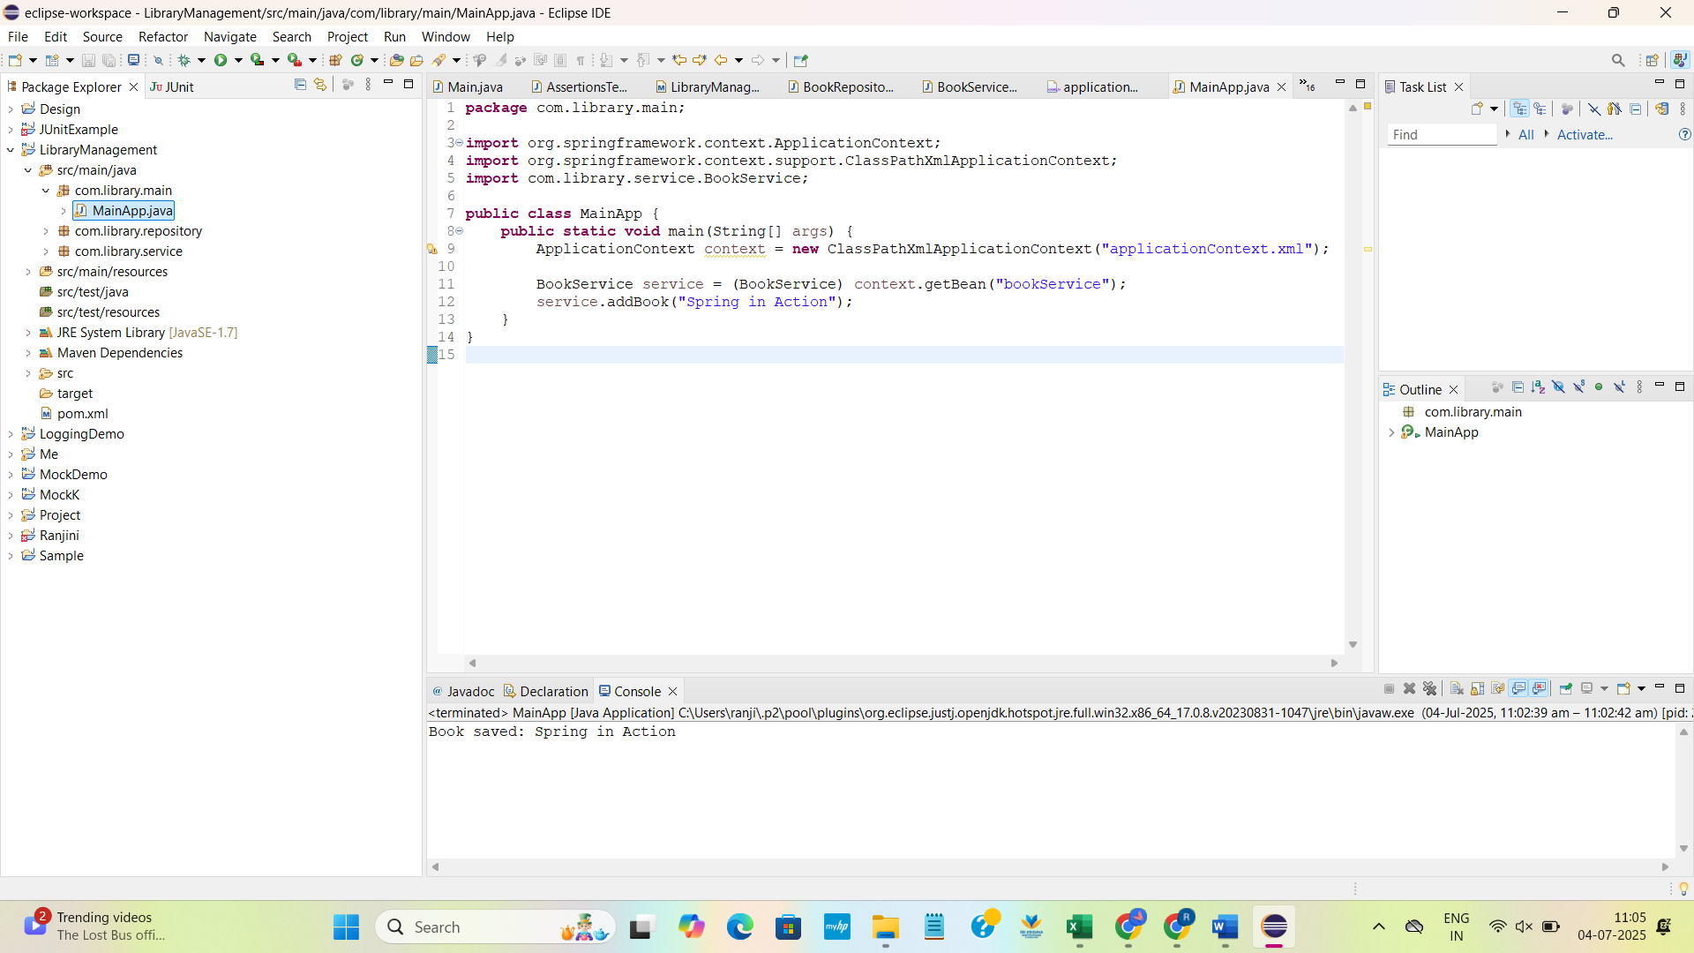

**Exercise 2: Implementing Dependency Injection**

**Scenario:**

In the library management application, you need to manage the dependencies between the BookService and BookRepository classes using Spring's IoC and DI.

**Steps:**

1. Modify the XML Configuration:
   * Update applicationContext.xml to wire BookRepository into BookService.
2. Update the BookService Class:
   * Ensure that BookService class has a setter method for BookRepository.
3. Test the Configuration:
   * Run the LibraryManagementApplication main class to verify the dependency injection.

**CODE:**

**BookRepository.java:**

package com.library.repository;

public class BookRepository {

public void saveBook(String bookName) {

System.*out*.println("Saving book: " + bookName);

}

}

**BookService .java:**

package com.library.service;

import com.library.repository.BookRepository;

public class BookService {

private BookRepository bookRepository;

public void setBookRepository(BookRepository bookRepository) {

this.bookRepository = bookRepository;

}

public void addBook(String name) {

bookRepository.saveBook(name);

}

}

**Applicationcontext.java:**

<?xml version="1.0" encoding="UTF-8"?>

<beans xmlns="http://www.springframework.org/schema/beans"

xmlns:xsi="http://www.w3.org/2001/XMLSchema-instance"

xsi:schemaLocation="http://www.springframework.org/schema/beans

http://www.springframework.org/schema/beans/spring-beans.xsd">

<bean id="bookRepository" class="com.library.repository.BookRepository" />

<bean id="bookService" class="com.library.service.BookService">

<property name="bookRepository" ref="bookRepository"/>

</bean>

</beans>

**MainApp.java:**

package com.library.main;

import org.springframework.context.ApplicationContext;

import org.springframework.context.support.ClassPathXmlApplicationContext;

import com.library.service.BookService;

public class MainApp {

public static void main(String[] args) {

ApplicationContext context = new ClassPathXmlApplicationContext("applicationContext.xml");

BookService bookService = (BookService) context.getBean("bookService");

bookService.addBook("Effective Java");

}

}

OUTPUT: 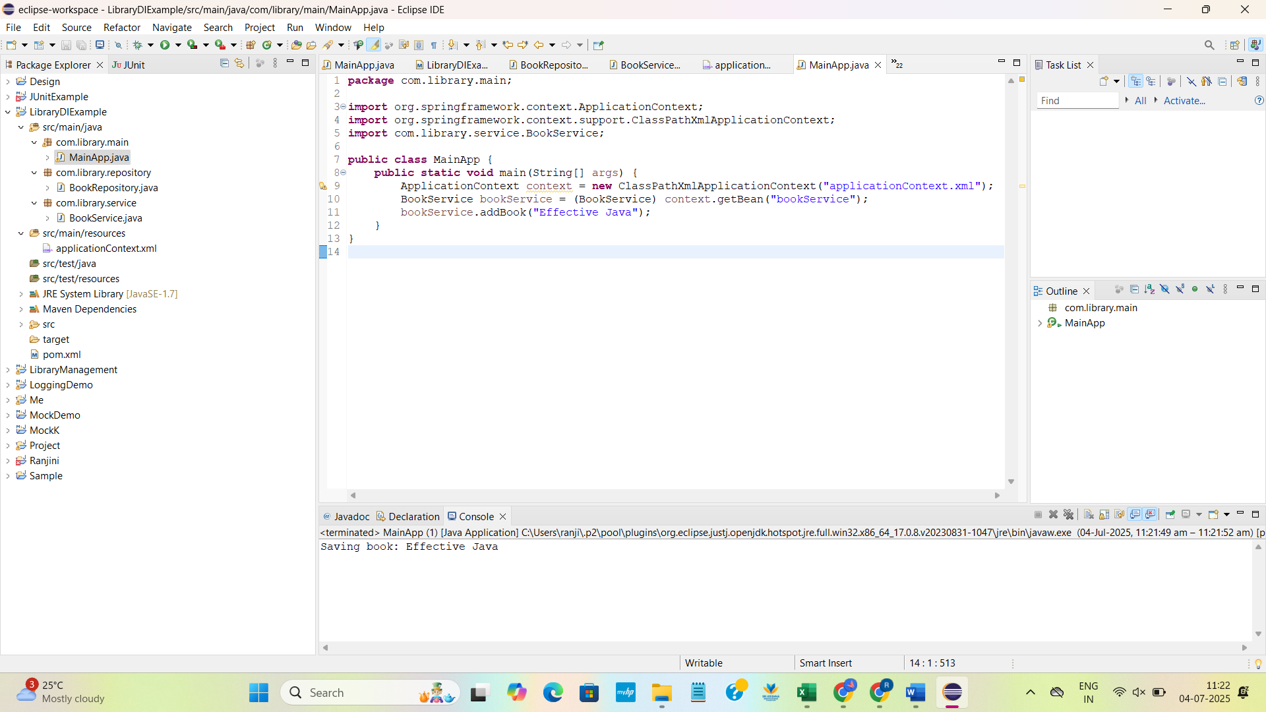

**Exercise 4: Creating and Configuring a Maven Project**

**Scenario:**

You need to set up a new Maven project for the library management application and add Spring dependencies.

**Steps:**

1. **Create a New Maven Project:**
   * Create a new Maven project named **LibraryManagement**.
2. **Add Spring Dependencies in pom.xml:**
   * Include dependencies for Spring Context, Spring AOP, and Spring WebMVC.
3. **Configure Maven Plugins:**
   * Configure the Maven Compiler Plugin for Java version 1.8 in the pom.xml file.

**CODE:**

<project xmlns="http://maven.apache.org/POM/4.0.0"

xmlns:xsi="http://www.w3.org/2001/XMLSchema-instance"

xsi:schemaLocation="http://maven.apache.org/POM/4.0.0

https://maven.apache.org/xsd/maven-4.0.0.xsd">

<modelVersion>4.0.0</modelVersion>

<groupId>com.library</groupId>

<artifactId>LibraryManagementt</artifactId>

<version>0.0.1-SNAPSHOT</version>

<properties>

<maven.compiler.source>1.8</maven.compiler.source>

<maven.compiler.target>1.8</maven.compiler.target>

</properties>

<dependencies>

<dependency>

<groupId>org.springframework</groupId>

<artifactId>spring-context</artifactId>

<version>5.3.22</version>

</dependency>

<dependency>

<groupId>org.springframework</groupId>

<artifactId>spring-aop</artifactId>

<version>5.3.22</version>

</dependency>

<dependency>

<groupId>org.springframework</groupId>

<artifactId>spring-webmvc</artifactId>

<version>5.3.22</version>

</dependency>

</dependencies>

<build>

<plugins>

<plugin>

<groupId>org.apache.maven.plugins</groupId>

<artifactId>maven-compiler-plugin</artifactId>

<version>3.8.1</version>

<configuration>

<source>1.8</source>

<target>1.8</target>

</configuration>

</plugin>

</plugins>

</build>

</project>

**OUTPUT:**

